**TECHNICAL DESIGN DOCUMENTS**

**Project Name: Farming Assistance System**

**Team Members: Team Mentor:**

**Gaurav Mohanty Vishal Soni**

**Harshit Joshi**

**Manoj kumar M**

**Reema Kumari**

**Yash Raj**

**Introduction**

This is a web based application to help the farmers working with the motive of greater profitability by direct communication between farmer to supplier and supplier to farmer. This integrated system contains the Farmer component, the Supplier component and the Admin component. It provides an option of login to farmers and communicates to respective suppliers.

Farmers are notified whenever suppliers publish an advertisement or offer on website through SMS message. The farmers may also have an option to submit their grievances and complaints to respective dealers or authorities using their farmer login on a separate complaints page and authorities will get access to that page regularly using their login id and passwords.

**Functional Requirements:**

The functional requirements of the project are:

**For the Admin:**

* Add the tips
* Delete the tips
* Update the tips
* View complaints
* Update complaints

**For the Farmer:**

* View tips
* View advertisement
* Add crops
* Add complaint

**For the supplier**

* Add advertisement
* Update added crops

**Microservices**

* **Authentication service -** Farmers and Suppliers can login into the system with their login credentials. New Farmers and Suppliers can sign up into the system. Farmers and Suppliers can update or delete their account. Admin can login into the system with their credentials.
* **Farming tips service -** Admin can add farming tips for the farmers. Admin can update and delete the farming tips. Farmers can view the farming tips.
* **Advertisement service -** Supplier can add an advertisement for the farmers. Farmers will get a notification through SMS.
* **Complaint service -** Farmers can add/submit their complaints. Admin can view the complaint added by farmers. Admin can update the complaint to read/solved.
* **Crops service -** Farmers can add crops to sell. Suppliers can update the added crops by farmer to (accept/reject) if all the supplier’s requirements are satisfied.

**Overall Architecture Diagram:**

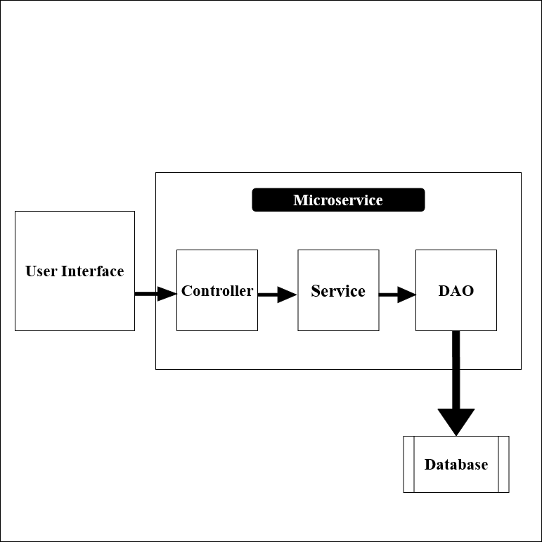

**E-R Diagram:**

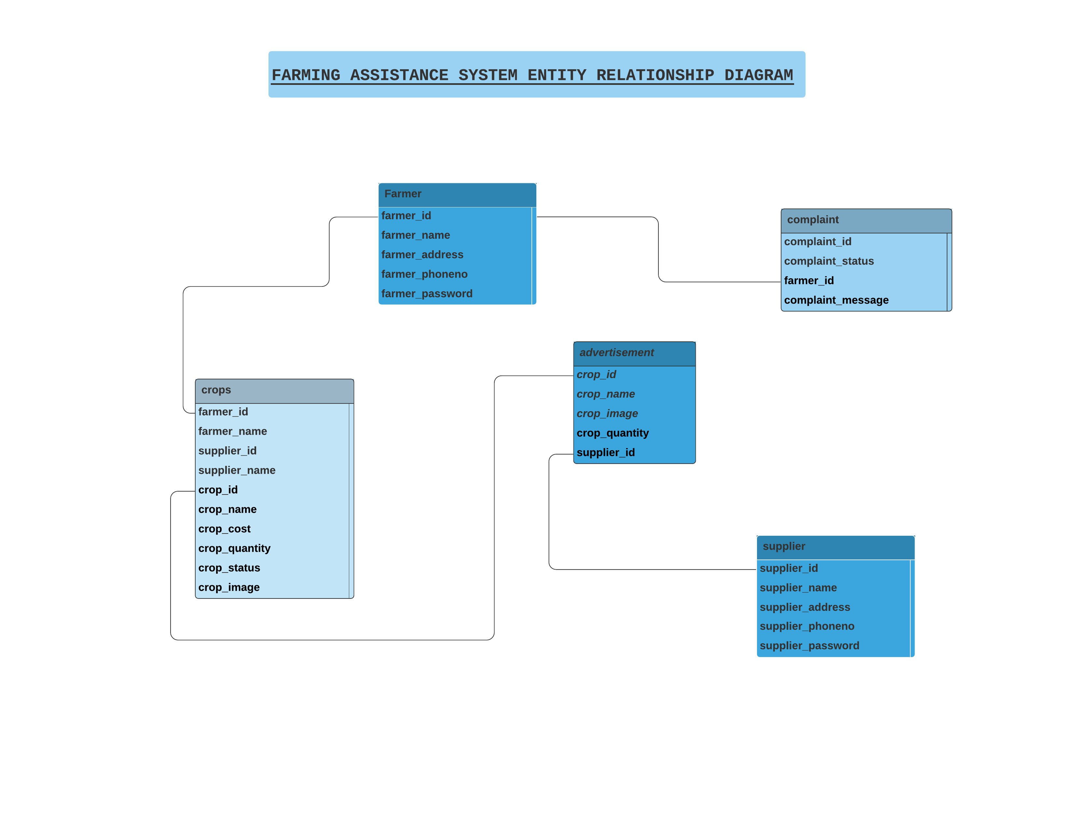

**Sequence Diagram:**

**Farmer:**

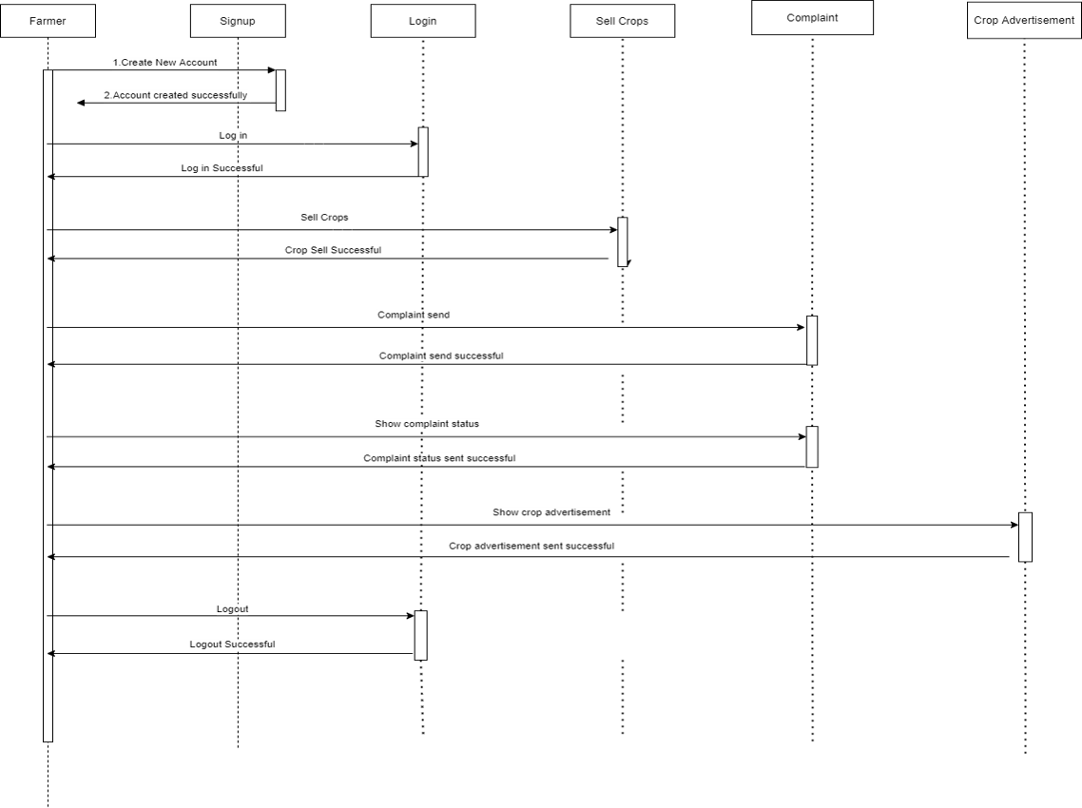

**Admin:**

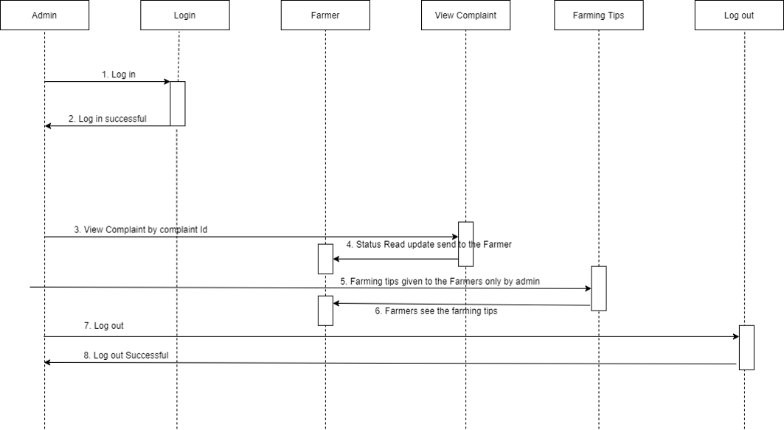

**Supplier:**

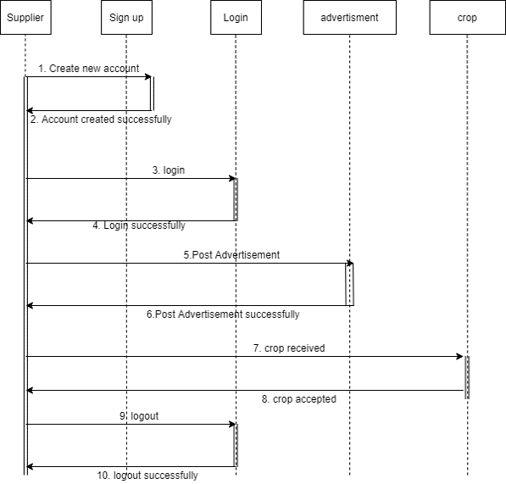

**Wireframe**

# **Authentication Service:**

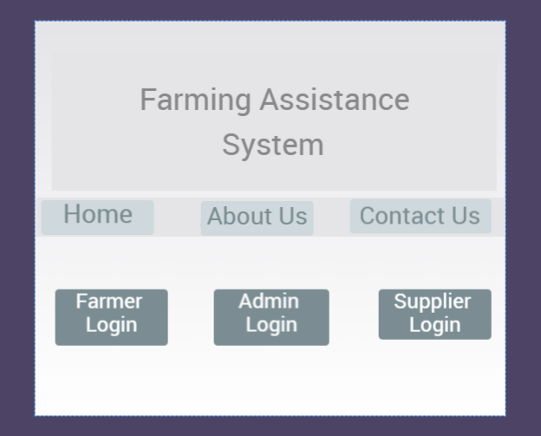

**Homepage**

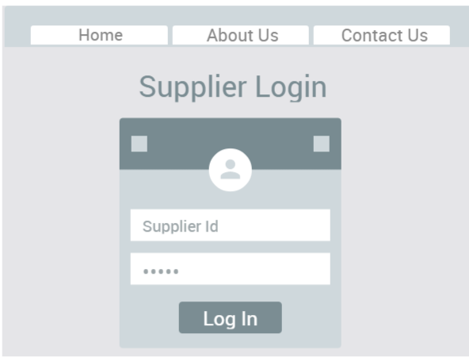

**Supplier Login**

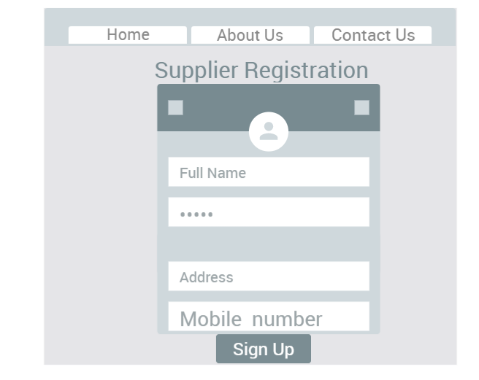

**Supplier Signup**

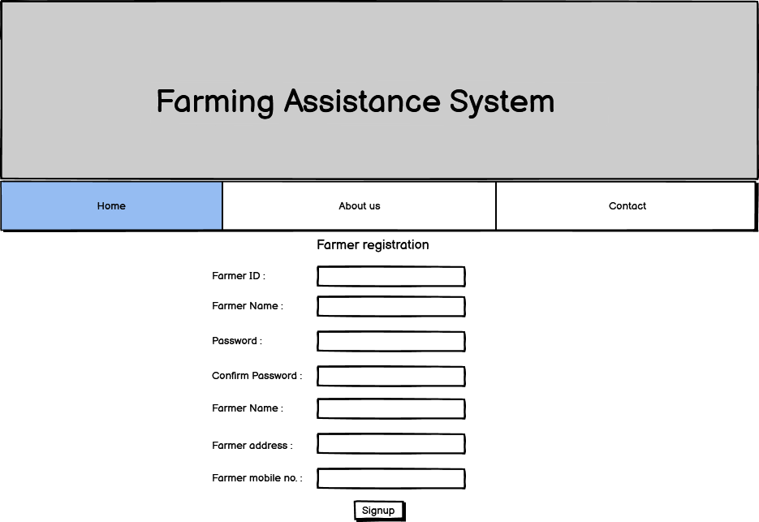

**Farmer signup**

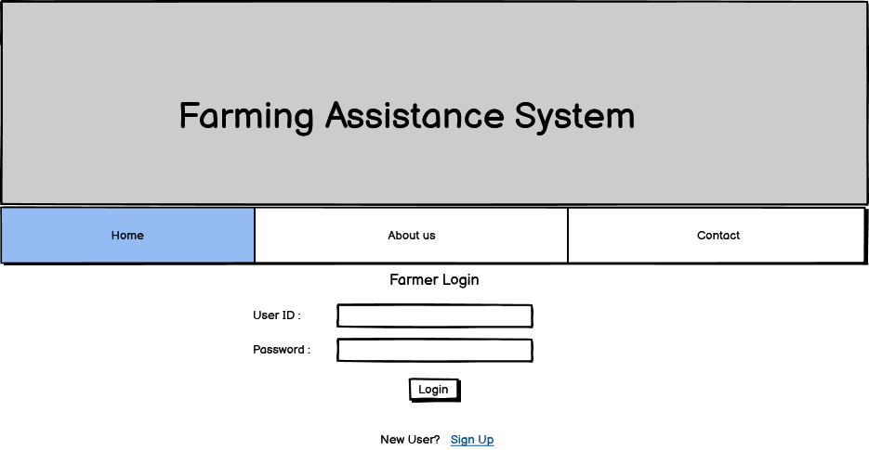

**Farmer Login**

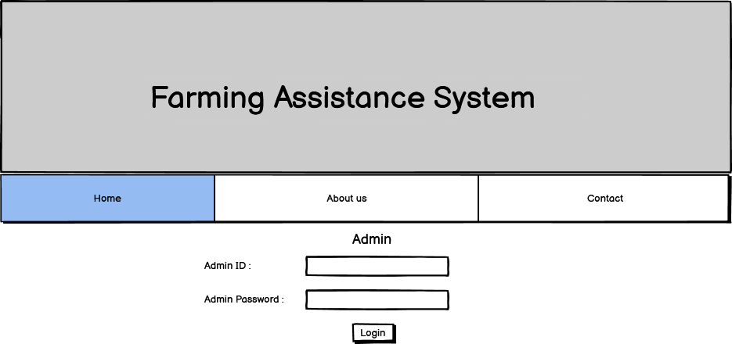

**Admin Login**

# **Crops Service:**

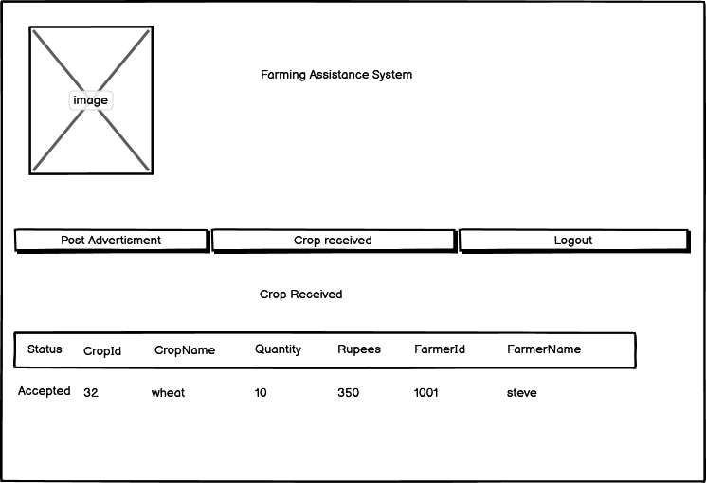

**Update added crop**

**Advertisement Service:**

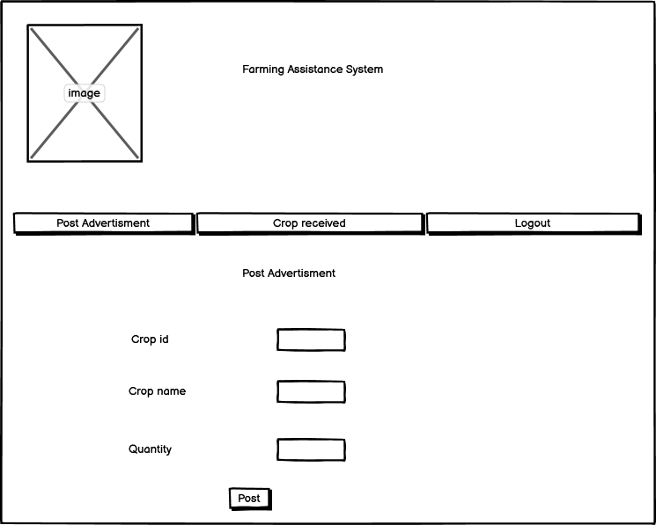

**Add advertisement**

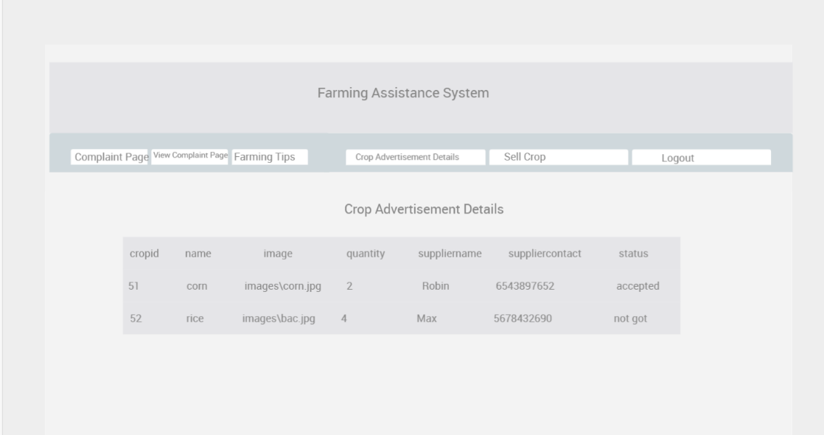

**View Advertisement details**

# **Complaint service**

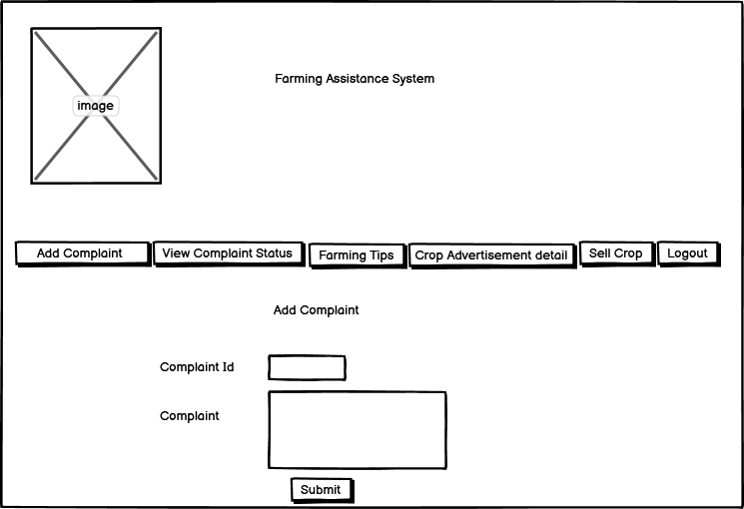

**Add Complaint**

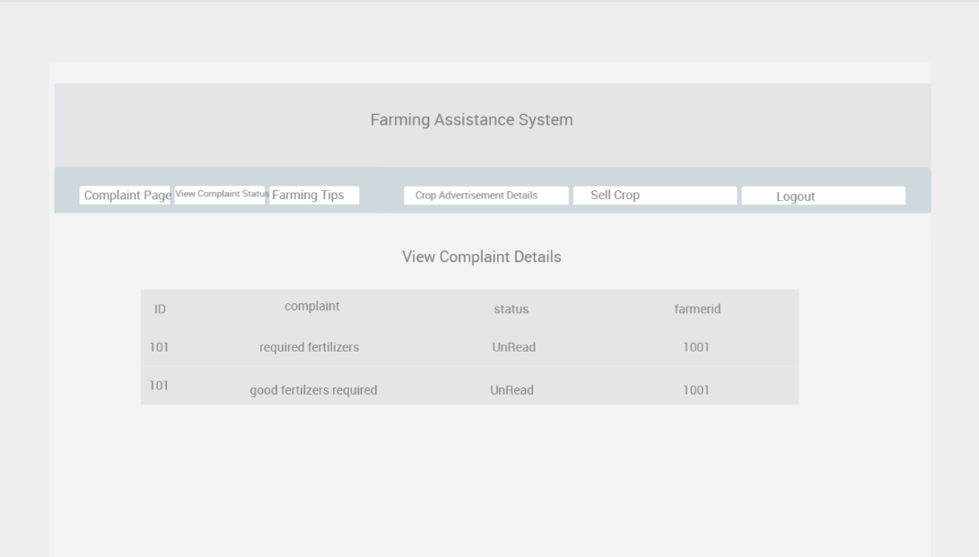

**View/Update Complaint**

# 

# **Farming Tips service**

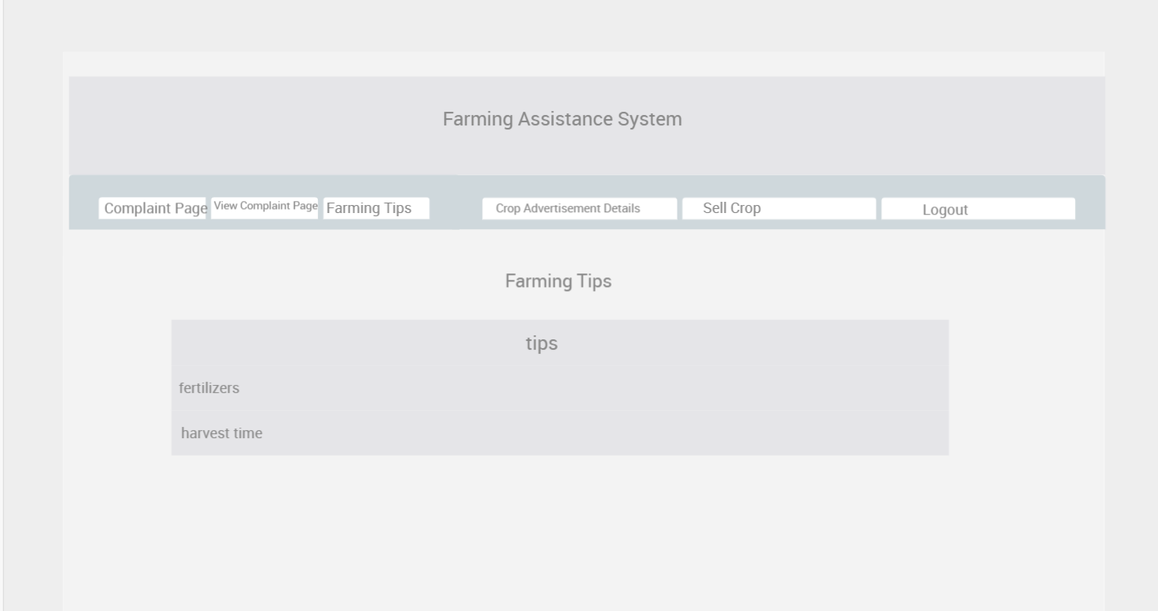

**View Tips**